**

**Mathematics Specialist Unit 1**

# Test 3

**Geometry, Combinatorics and Vectors**

|  |
| --- |
| **Name: ______________________ Total Marks:__________** |
|  |
|  |

**Task type: Response**

**Time allowed for this task:** 60 minutes, in-class, under test conditions

Section One: Calculator-free 20 minutes (20 marks)

Section Two: Calculator-assumed 40 minutes (40 marks)

**Materials required:** Calculator with CAS capability (to be provided by the student)

**Standard items:** Pens (blue/black preferred), pencils (including coloured), sharpener, correction fluid/tape, eraser, ruler, highlighters

**Special items:**  Drawing instruments, templates, notes on one unfolded sheet of   
A4 paper, and up to three calculators approved for use in the WACE examinations

Formula sheet

**Marks available: 60 marks**

**Task weighting: 6%**

**Section One : Calculator Free Marks 20**

**Time Allowed 20 minutes**

**Question 1**

[6 marks]

Consider the statement

“If a quadrilateral is a square, then it has 4 equal angles”

1. Write the inverse statement.
2. Write the converse statement.
3. Write the contrapositive statement.
4. Which of these statements are false? Give a counter example

**Question 2**

Determine whether or not $A⇔B$

[2 marks]

A: The two triangles are congruent.

B: The two triangles have corresponding angles equal.

**Question 3**

[2 marks]

A teacher gives her class of 7 students a piece of paper each and asks them to write down a permutation of the letters of the word CAR that uses all three letters once and once only.

Every student performs this correctly and the teacher collects the 7 pieces of paper. What can we conclude about the responses and why?

**Question 4**

[5 marks]

Using the method of proof by contradiction. Prove that if $3n+2$ is odd then $n$ is odd.

**Question 5**

[5 marks]

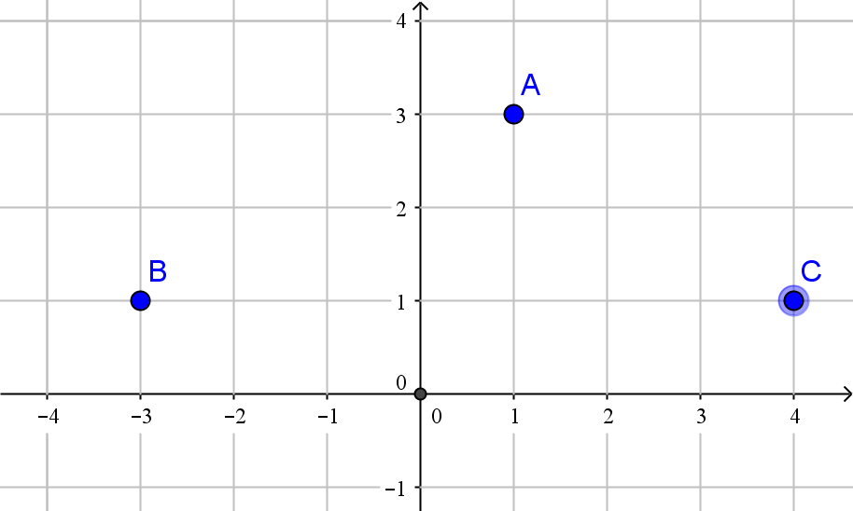

Write in the for $m ai+bj$

1. The position vector of A
2. The position vector of B
3. The displacement of A relative to C
4. The displacement of B relative to A
5. The displacement of a point D relative to B is $4i-j$**.** What is the position vector of D

**Section Two : Calculator Assumed Mark 40**

**Time Allowed 40 minutes Name:_______________________**

**Question 6**

[8 marks]

1. 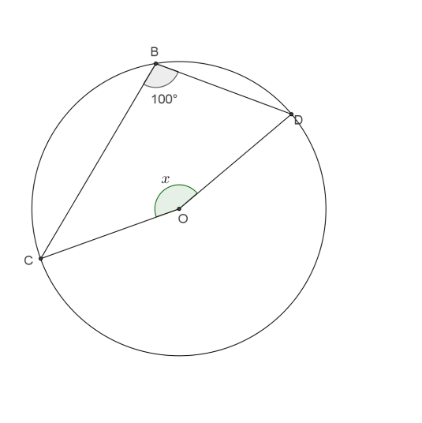Find the value of $x$, showing appropriate reasoning.
2. 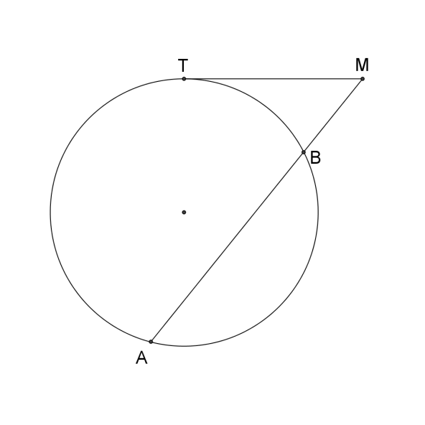Given that TM=6m and BM=4m. Find AB

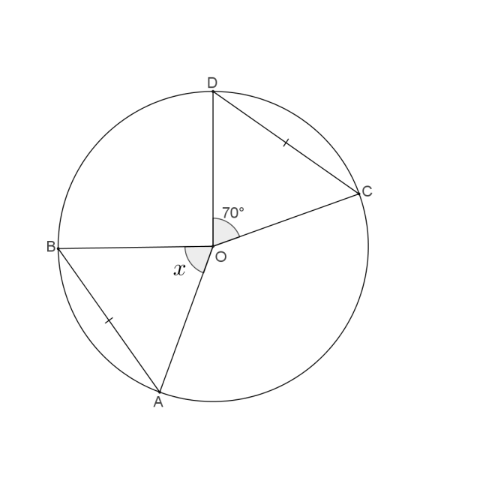

1. Find the value of $x$, showing appropriate reasoning.

**Question 7**

[5 marks]

A boat is travelling at 20km/h on bearing of 150⁰. Relative to a person on the boat, the wind appears to come from the east with a speed of 8km/h. Find the actual speed and bearing of the wind.

**Question 8**

[8 marks]

A four digit code is to be chosen using the digits 0, 1, 2, 3, 4 such that no digit can be used more than once.

How many codes :

1. can be formed?
2. begin with 4?
3. are an odd number?
4. start and end in an odd number?
5. are less than 400?

A code of two digits is to chosen from the digits 0, 1, 2, 3, 4 or the digits 2, 4, 6, 8.

How many two-digit codes are possible?

**Question 9**

[5 marks]

In the diagram below EA and EC are tangents to the curve

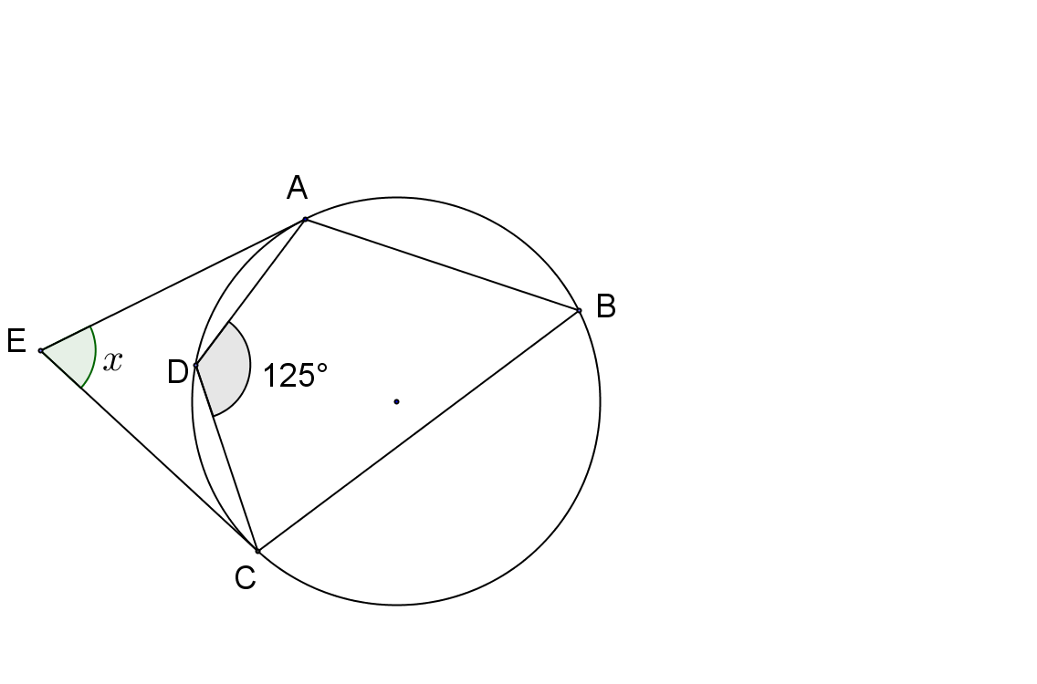 $∠AEC=x° .$ Prove that $x=70$

**Question 10**

[6 marks]

Prove that CE is the diameter of the circle.

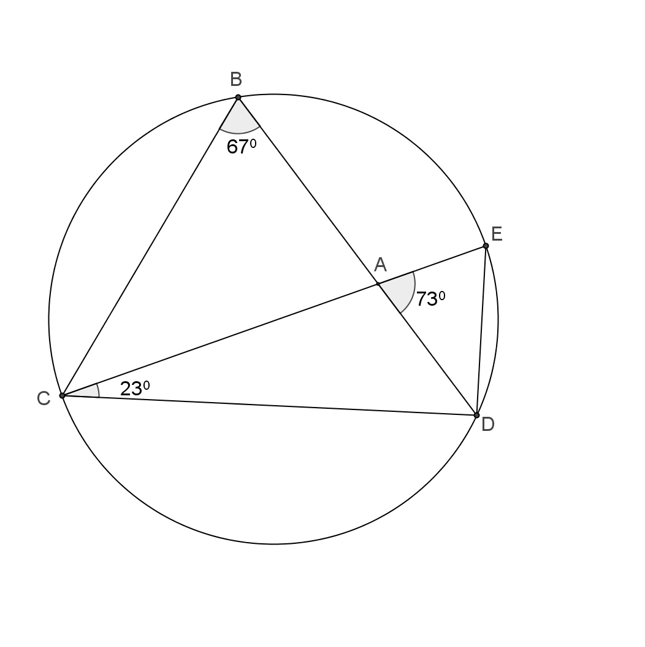

**Question 11**

[8 marks]

1. Prove that $AB×AD=AC×AE$

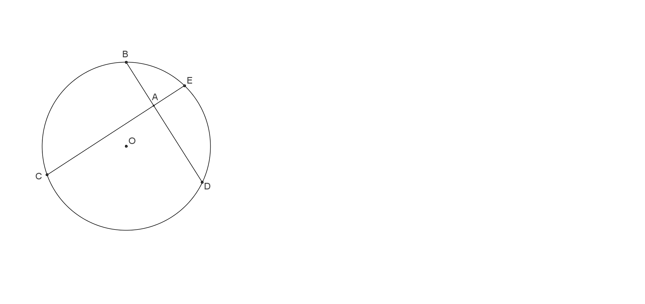

1. Given that AB=4cm, AD=6cm and 2AE=AD. Find the ED.